ASSIGNMENT NO.7: Subqueries and Nested Queries

Student Name | Anushka Pachpute | Roll Number | 20971
Batch | SY. BSc Data Science | Topic | WB(Assignment-7)

Q1) Create a MySQL database named CollegeDB and create two tables: Course and StudentResult.

Course Table
Column Name | Data Type | Constraint
CourseID | INT | PRIMARY KEY
CourseName | VARCHAR(50) | NOT NULL
Fees | DECIMAL(10,2) | NOT NULL

StudentResult Table
Column Name | Data Type | Constraint
StudentID | INT | PRIMARY KEY
StudentName | VARCHAR(50) | NOT NULL
CourseID | INT | FOREIGN KEY
City | VARCHAR(30)
Marks | INT

Insert at least 4 records into Course and 10 records into StudentResult.

QUERY:
CREATE DATABASE CollegeDB;
USE CollegeDB;

CREATE TABLE Course (
CourseID INT PRIMARY KEY,
CourseName VARCHAR(50) NOT NULL,
Fees DECIMAL(10,2) NOT NULL
);

CREATE TABLE StudentResult (
StudentID INT PRIMARY KEY,
StudentName VARCHAR(50),
Course VARCHAR(30),
City VARCHAR(30),
Marks INT,
FeesPaid DECIMAL(10,2)
FOREIGN KEY (CourseID) REFERENCES Course(CourseID)
);

INSERT VLAUES:
INSERT INTO course (CourseID, CourseName, Duration, Fees, Tier) VALUES
(101, 'B.Sc IT', '3 Years', 35000.00, NULL),
(102, 'BCA', '3 Years', 40000.00, NULL),
(103, 'BBA', '3 Years', 50000.00, NULL),
(104, 'Bsc DATA SCIENCE', '3 Years', 60000.00, NULL),
(105, 'MCA', '3 Years', 45000.00, NULL),
(106, 'B.Com', '3 Years', 60000.00, NULL),
(107, 'CSE', '4 Years', 80000.00, NULL),
(108, 'MSE', '2 Years', 50000.00, NULL);

INSERT INTO StudentResult
(StudentID, StudentName, Course, City, Marks, FeesPaid)
VALUES
(1, 'Amit Sharma', 'BCA', 'Pune', 85, 45000.00),
(2, 'Priya Patel', 'BCA', 'Mumbai', 92, 48000.00),
(3, 'Rahul Verma', 'BSc IT', 'Pune', 76, 42000.00),
(4, 'Neha Singh', 'BCA', 'Nashik', 88, 45000.00),
(5, 'Rohan Mehta', 'BSc IT', 'Mumbai', 69, 40000.00),
(6, 'Sneha Joshi', 'BCA', 'Nagpur', 95, 50000.00),
(7, 'Karan Shah', 'BSc CS', 'Pune', 81, 43000.00),
(8, 'Pooja Desai', 'BSc CS', 'Surat', 73, 41000.00),
(9, 'Vikas Kumar', 'BCA', 'Delhi', 64, 39000.00),
(10, 'Anjali Rao', 'BSc IT', 'Bangalore', 90, 47000.00);

OUTPUT:
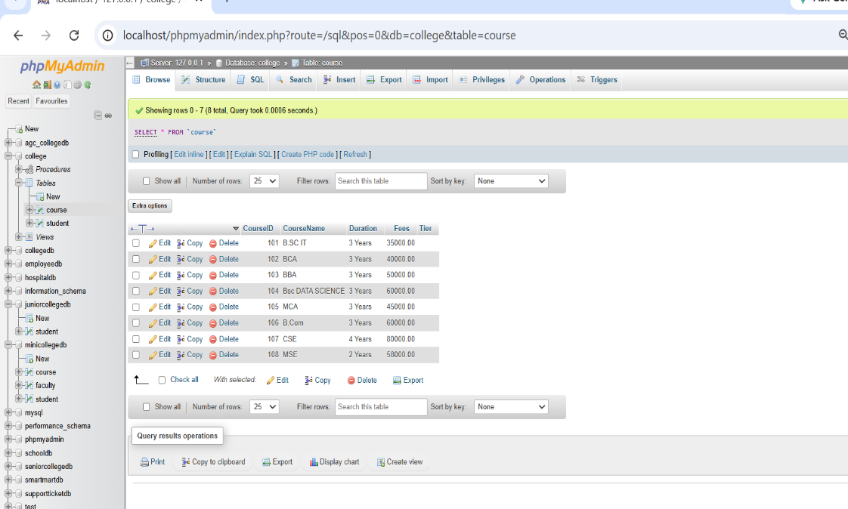

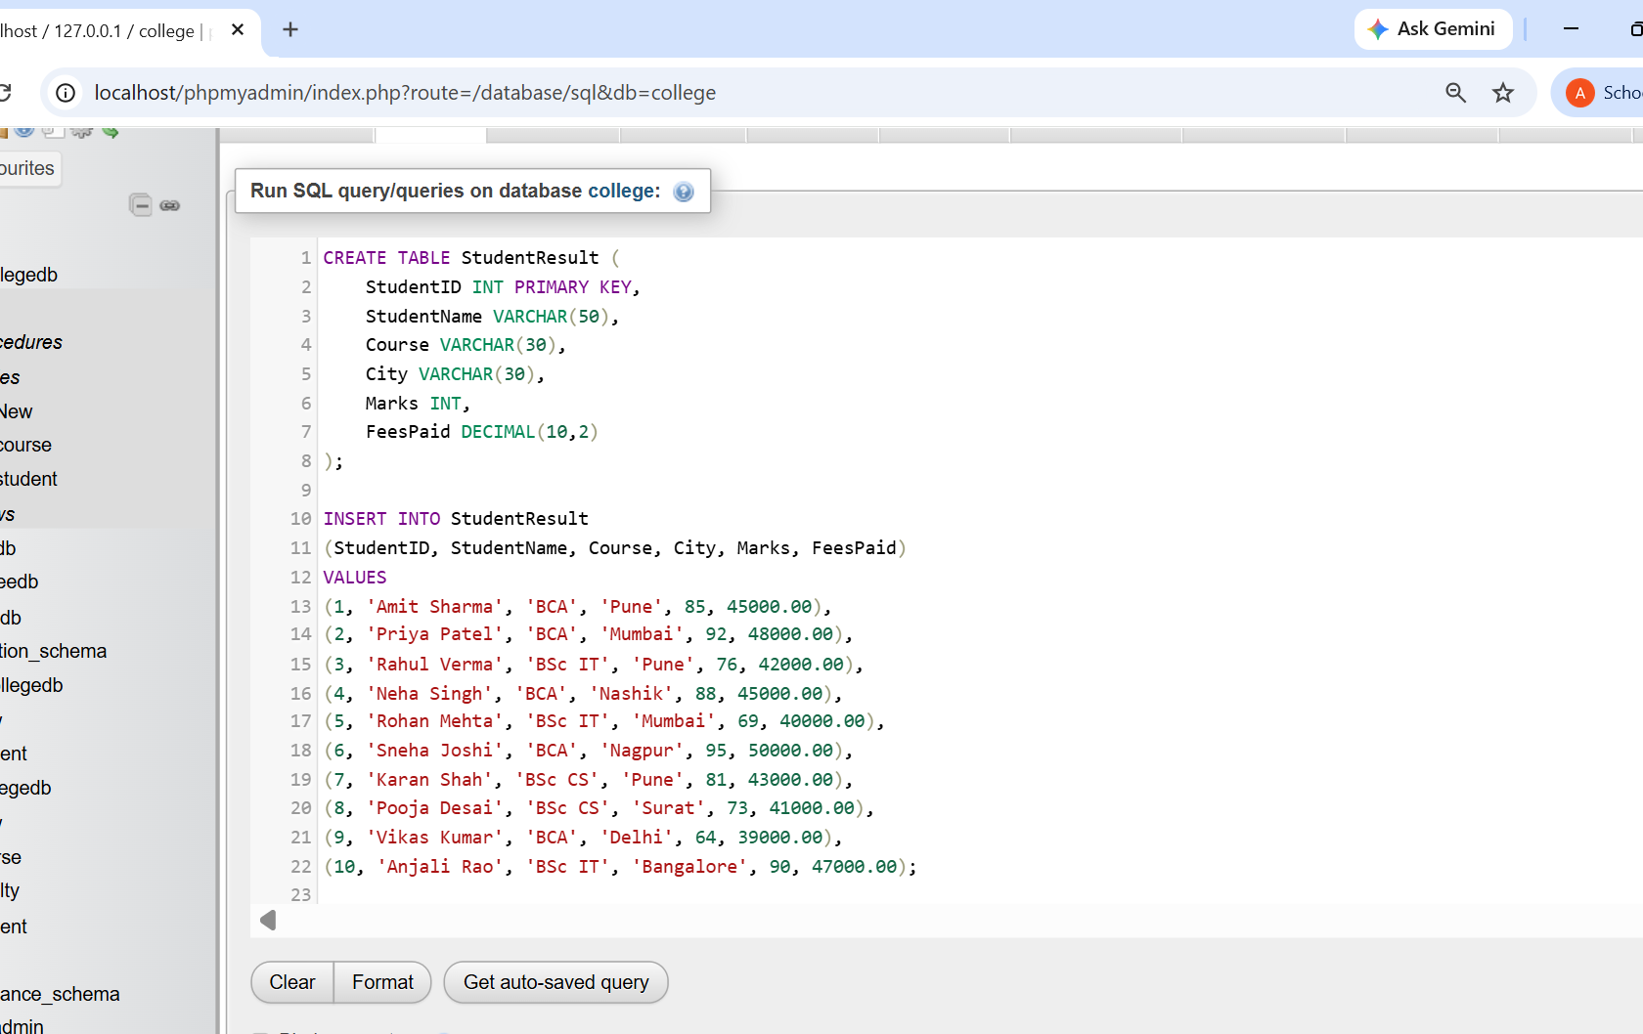

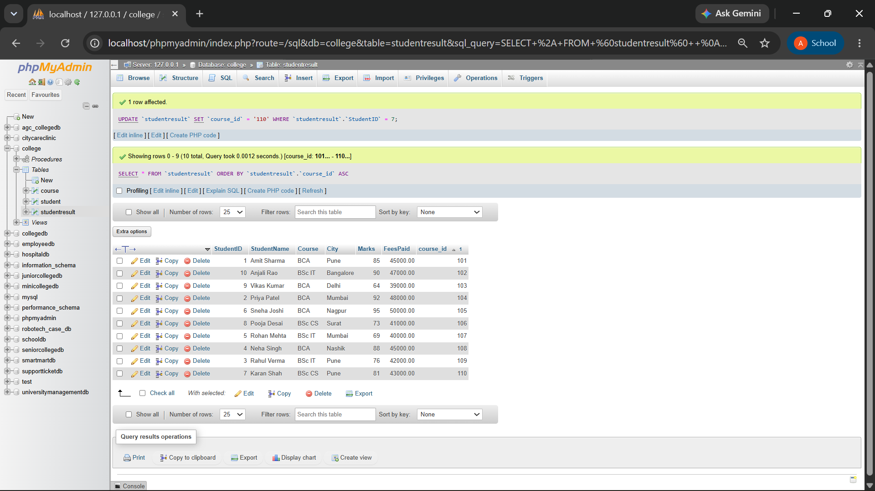

Q2) Write a MySQL query to display students whose marks are greater than the average marks of all students.
The output should contain:
Column
StudentName
Marks

QUERY:

SELECT StudentName, Marks FROM StudentResult

WHERE Marks > ( SELECT AVG(Marks)

FROM StudentResult

);

OUTPUT:

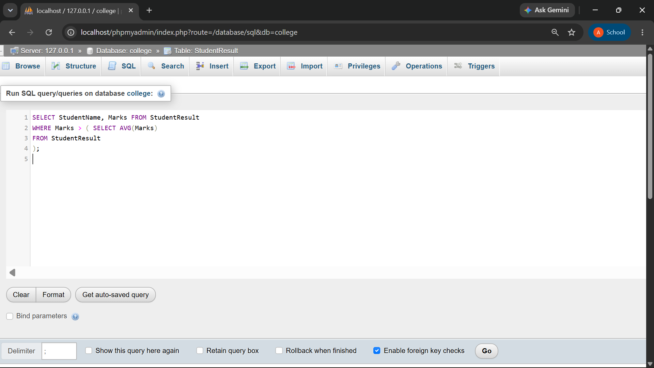
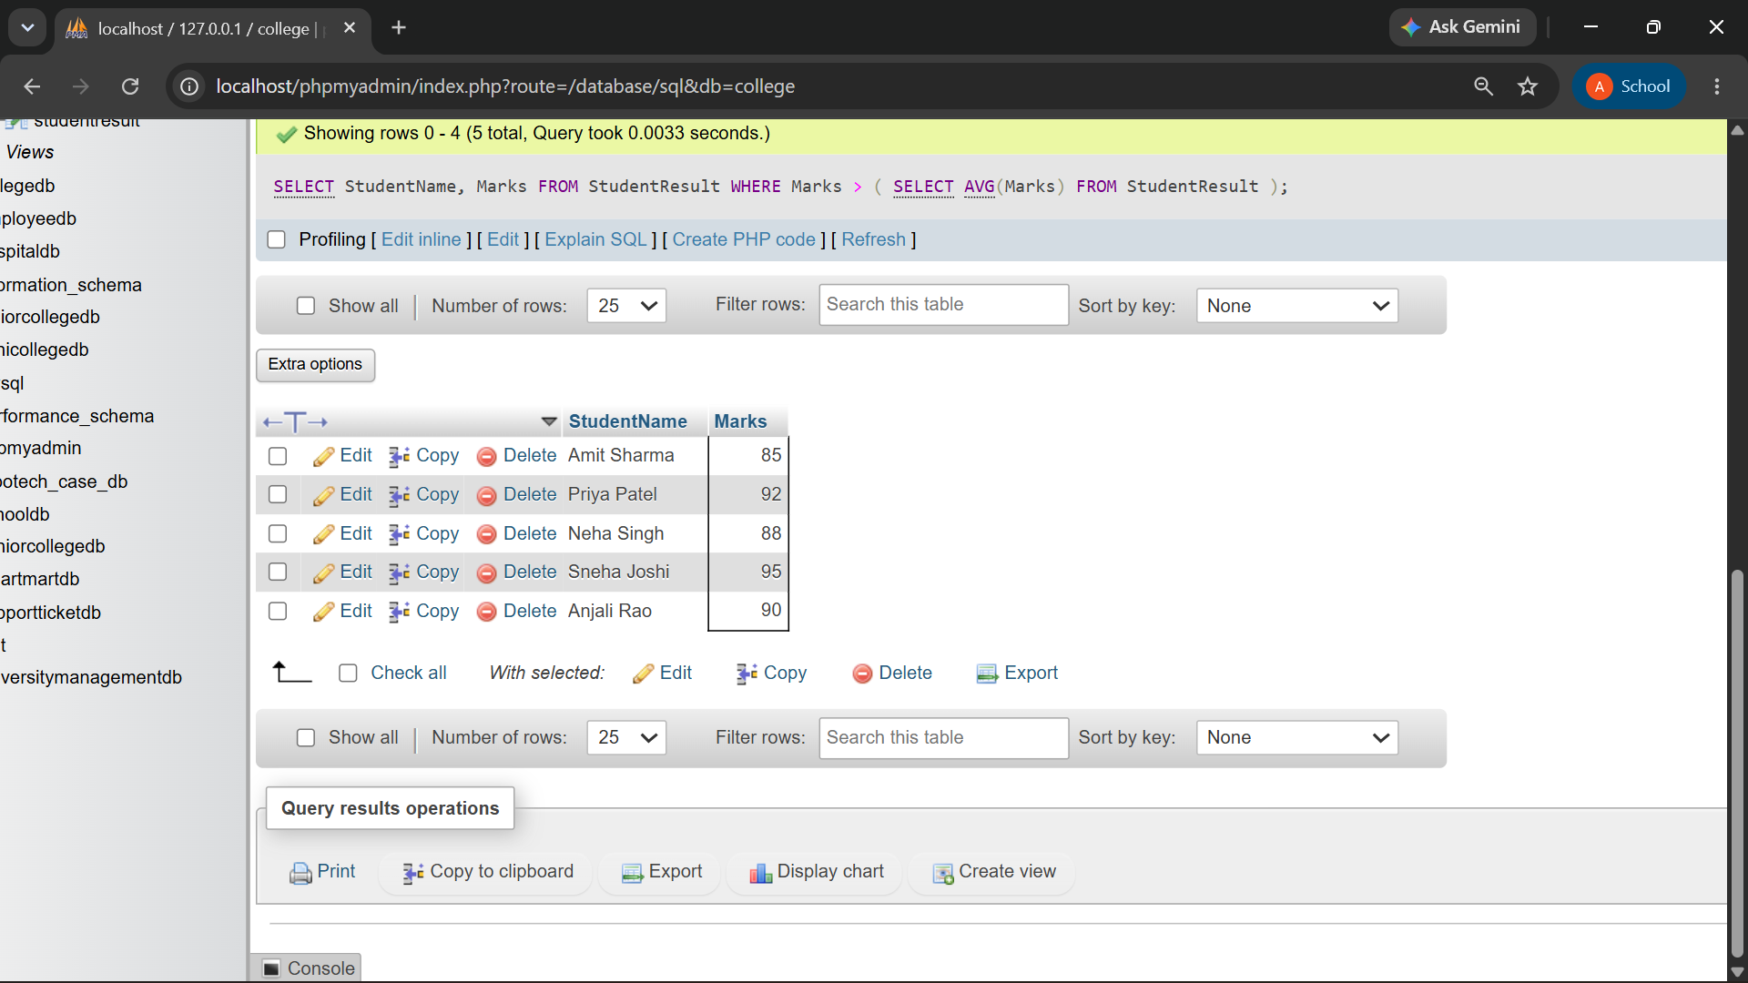

Q3) Write a MySQL query to display all students enrolled in the BCA course using a subquery.
The output should contain:
Column
StudentID
StudentName

Column
CourseID
Marks
QUERY:

SELECT StudentID, StudentName, CourseID, Marks FROM StudentResult

WHERE CourseID = ( SELECT CourseID FROM Course

WHERE CourseName = 'BCA'
);

OUTPUT:

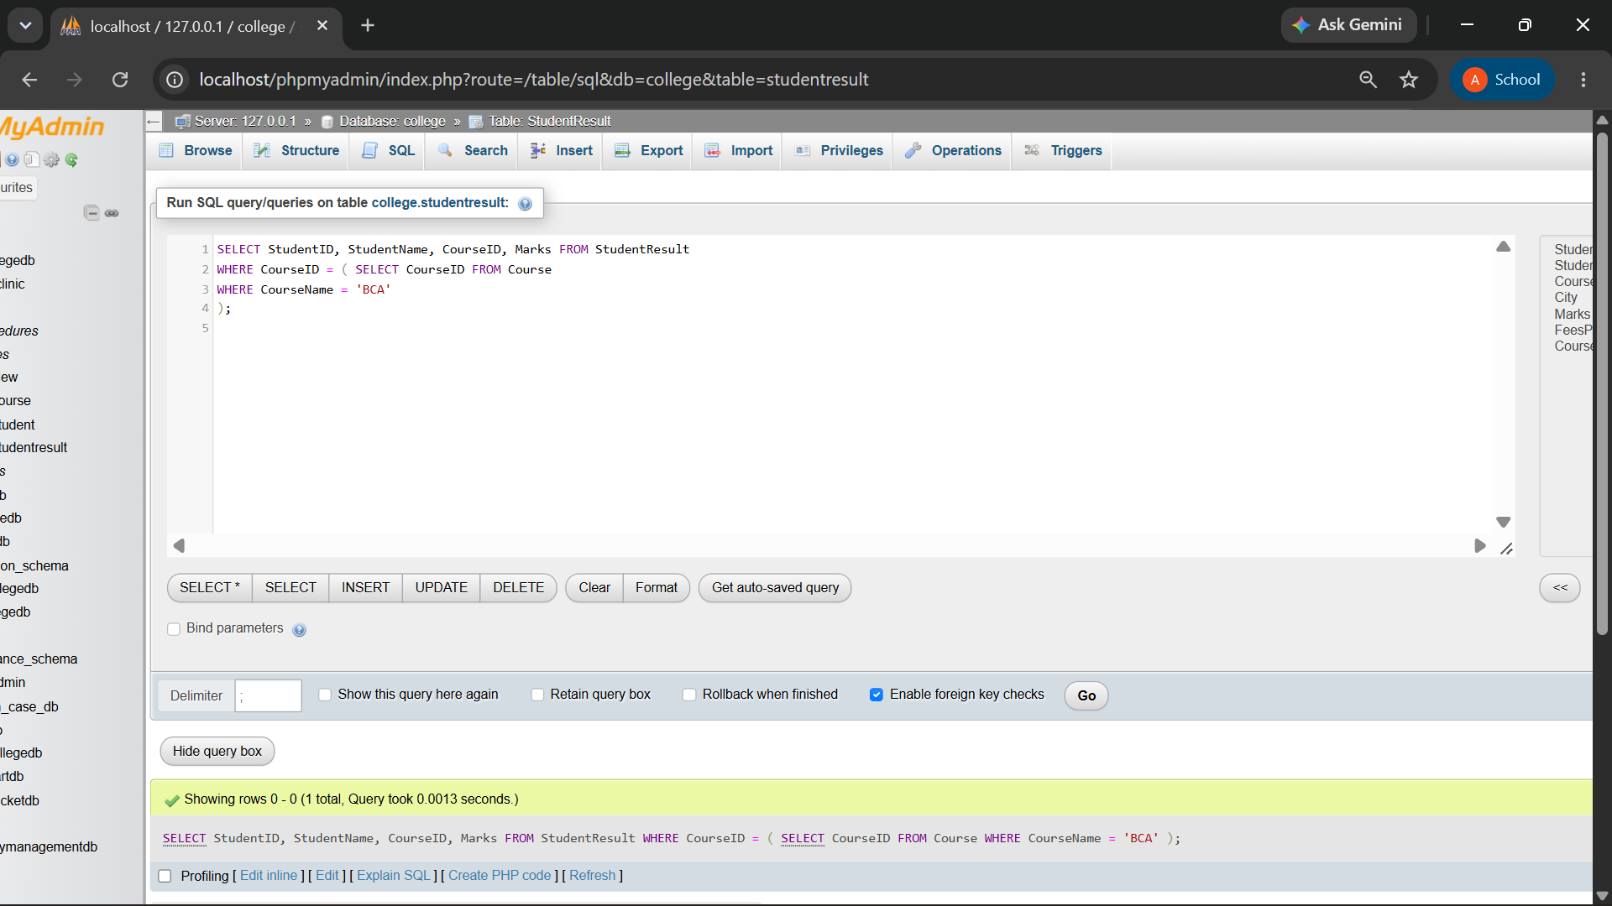
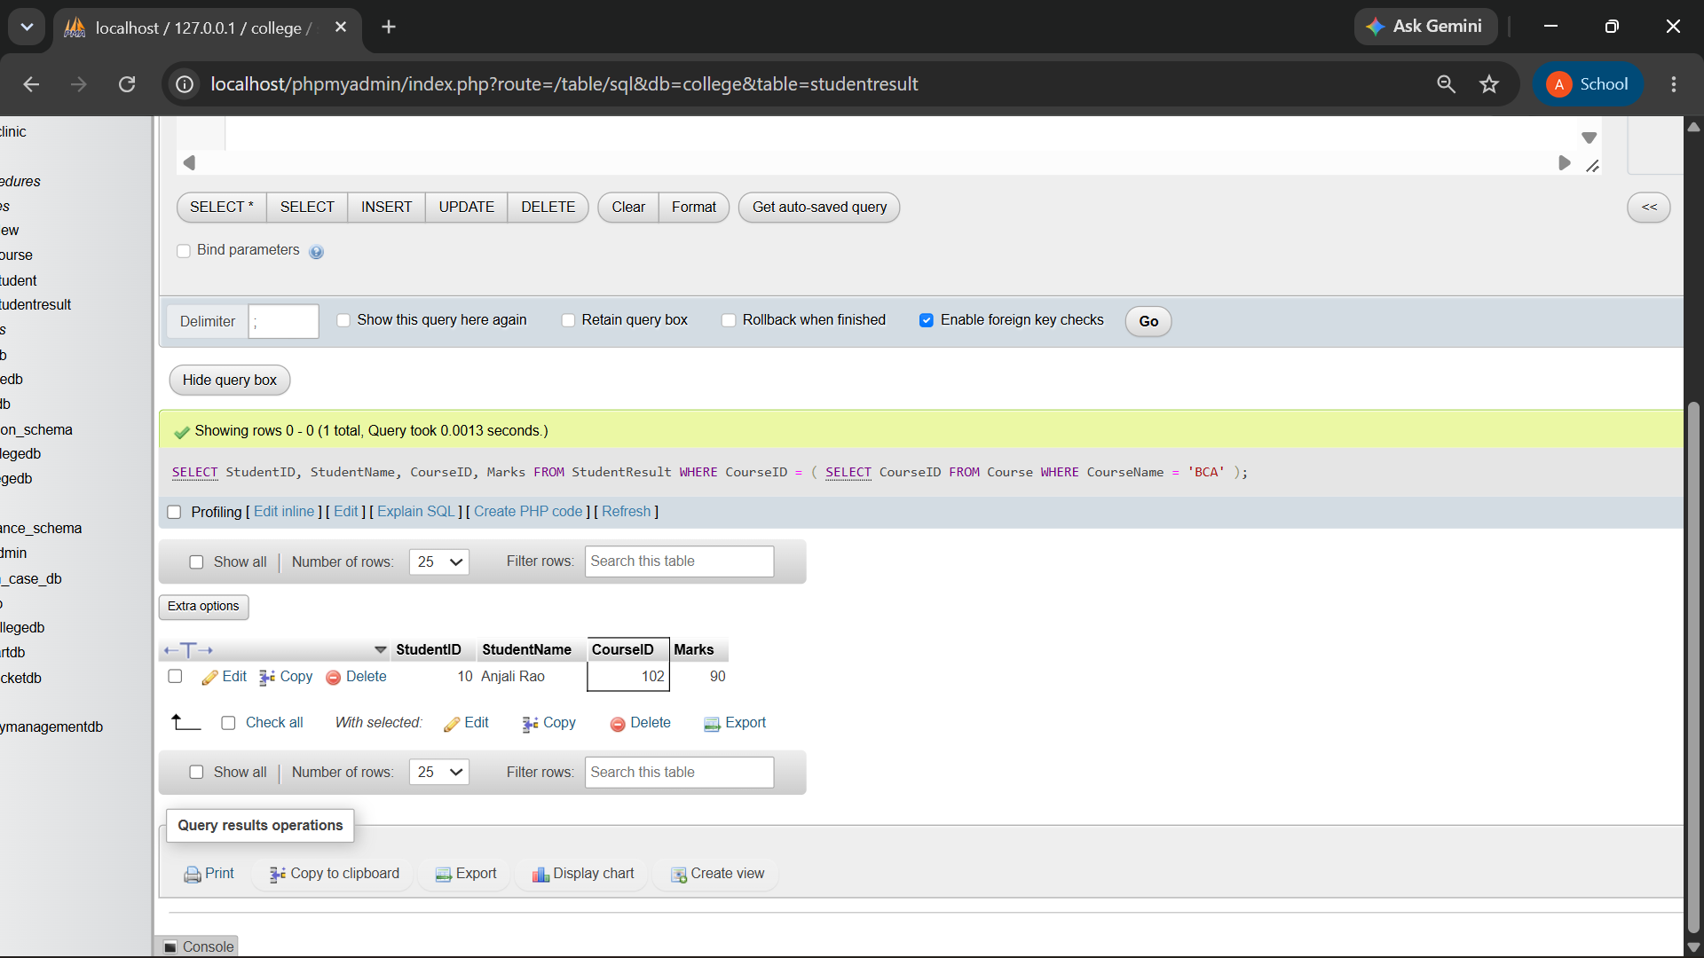

Q4) Write a MySQL query to display each student with the overall average marks using a subquery in the SELECT clause.
The output should contain:
Column
StudentName
Marks
AverageMarks

SELECT
StudentName,
Marks,
(SELECT AVG(Marks) FROM StudentResult) AS AverageMarks FROM StudentResult;

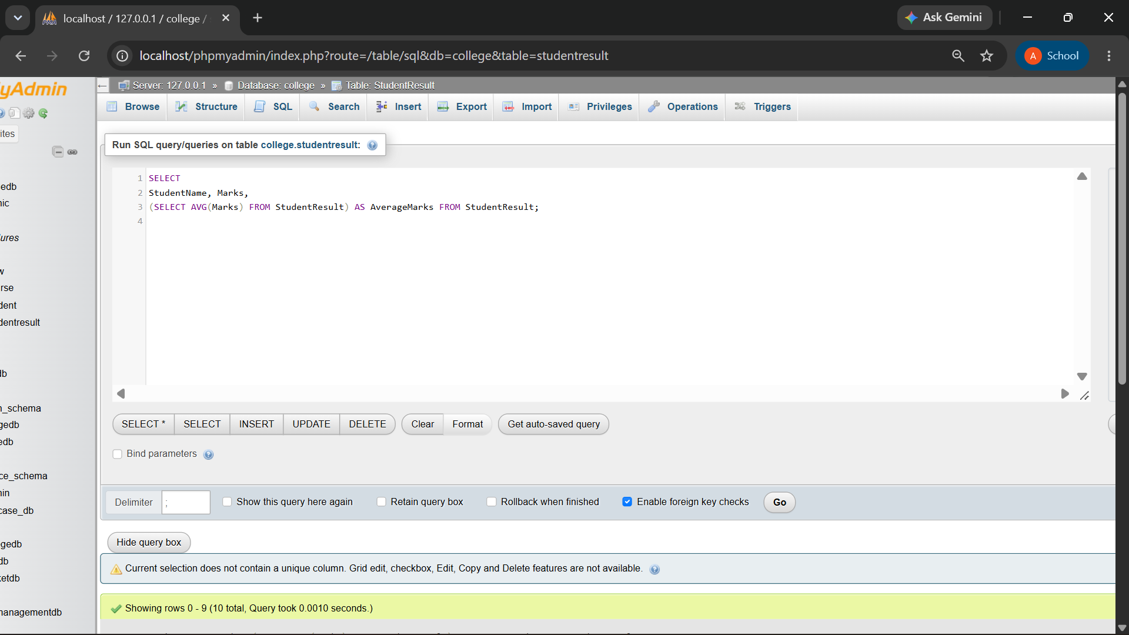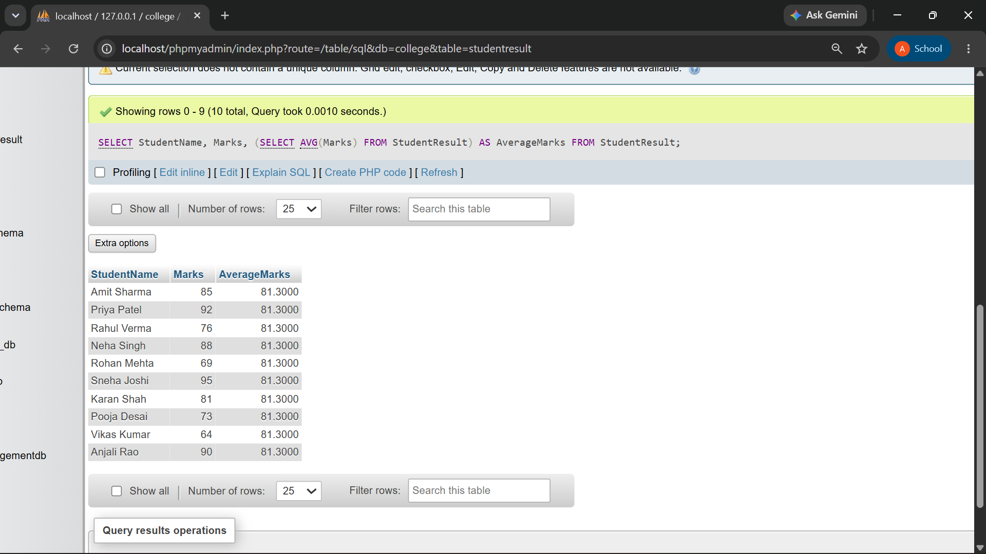

Q5) Write a MySQL query using a correlated subquery to display students who scored more than their own course average.
The output should contain:
Column
StudentID
StudentName
CourseID
Marks

QUERY:
SELECT StudentID, StudentName, CourseID, Marks FROM StudentResult S1
WHERE Marks > ( SELECT AVG(Marks)
FROM StudentResult S2
WHERE S2.CourseID = S1.CourseID
);

OUTPUT:

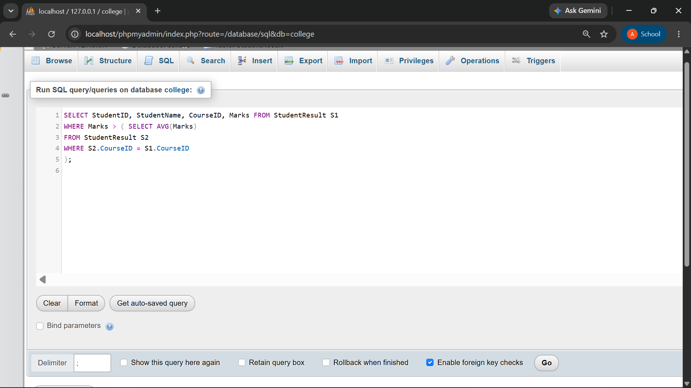
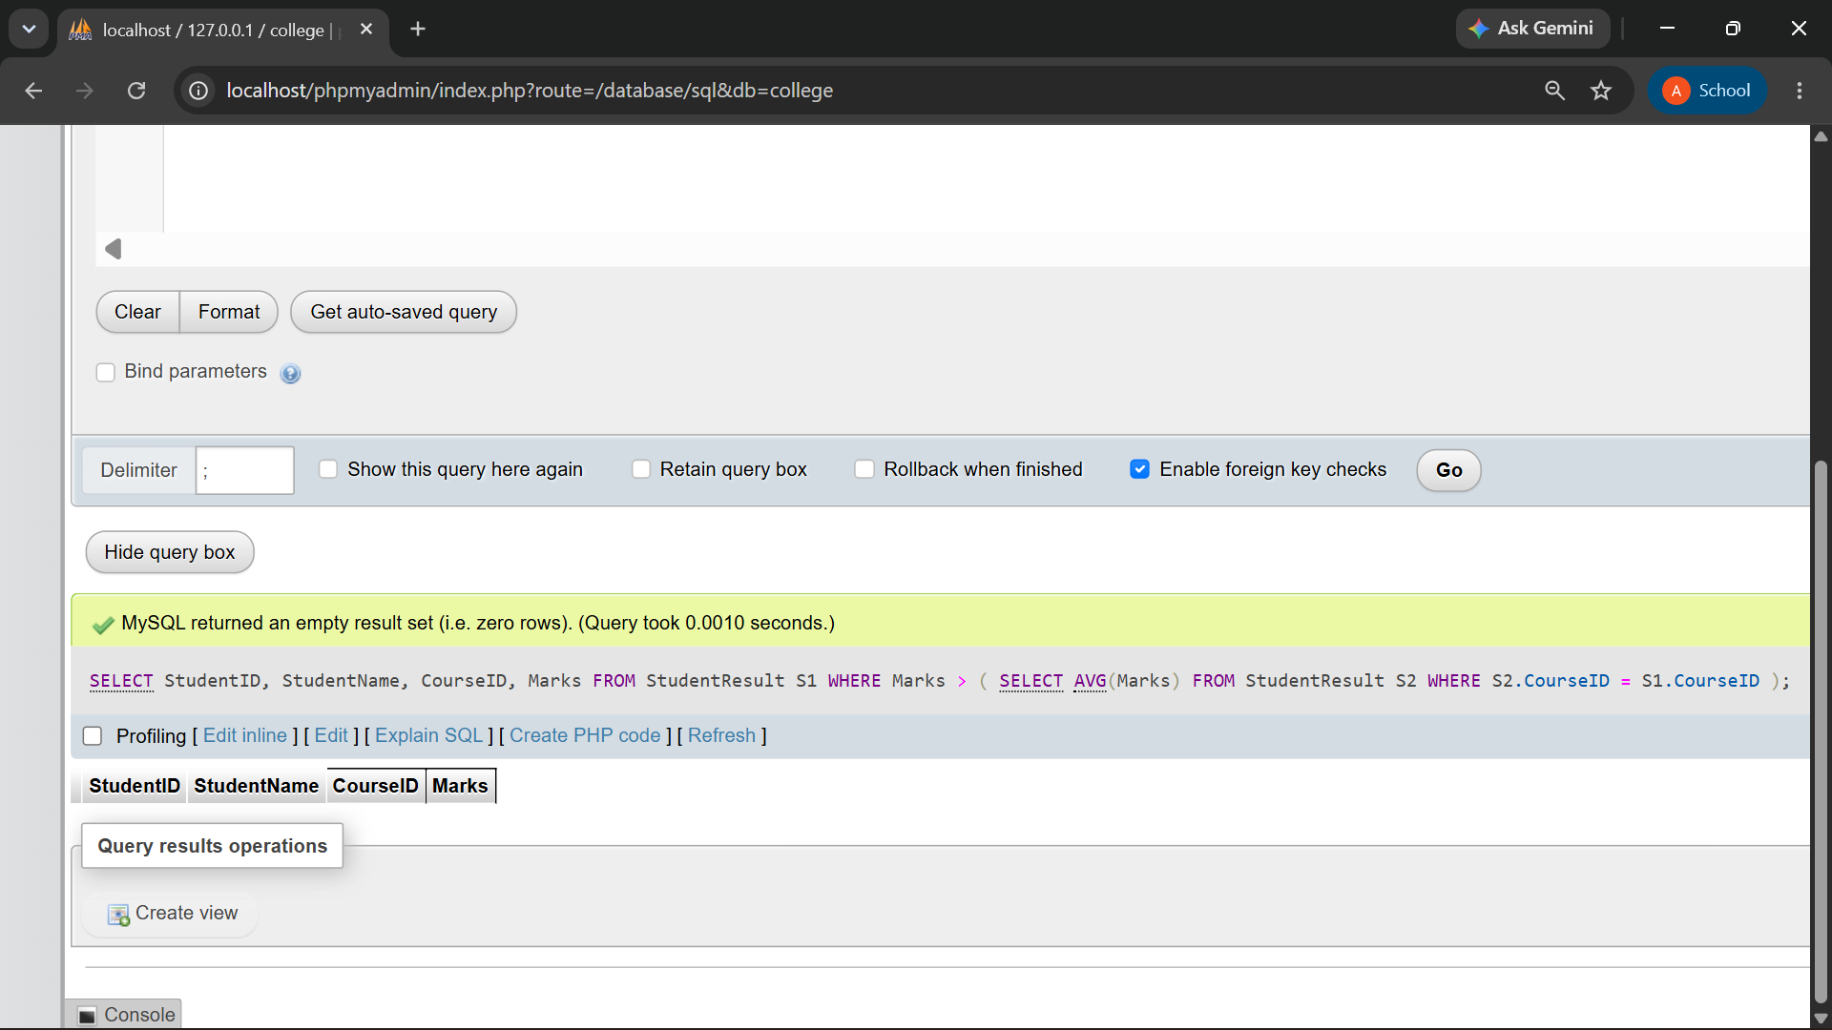

Q6) Write MySQL queries to display courses having students and courses having no students.
Use:
Operator
EXISTS
NOT EXISTS

QUERY:

Using EXISTS
SELECT CourseID, CourseName FROM Course C
WHERE EXISTS ( SELECT 1
FROM StudentResult S
WHERE S.CourseID = C.CourseID
);

Using NOT EXISTS

SELECT CourseID, CourseName FROM Course C
WHERE NOT EXISTS ( SELECT 1
FROM StudentResult S
WHERE S.CourseID = C.CourseID
);
OUTPUT:

